**Declarative Pipelines**

* <https://github.com/dummyrepos/game-of-life-july23/commit/fb5bc9db8f2c376f2585703f84958e3363665537> for the changeset which creates a declarative pipeline

**Email Notifications**

* For configuration use classroom video

**Activity:**

* Let’s send an email when the
  + project failed: your project is defective
  + project success: your project is effective

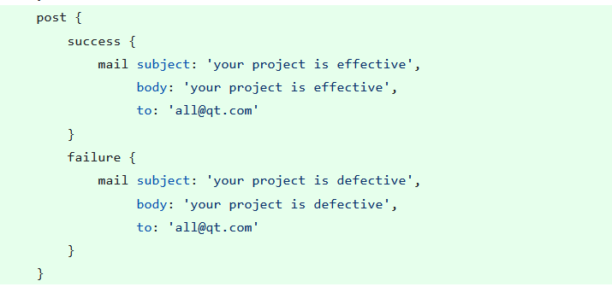

**Parameters from Jenkinsfile**

* <https://www.jenkins.io/doc/book/pipeline/syntax/#parameters> for docs
* <https://github.com/dummyrepos/game-of-life-july23/commit/c8c92f3826fa7a121835d89040a7a30f5aa503ef> for the changeset

**User Administration in Jenkins**

* Authentication
  + Jenkins own user database
  + LDAP
  + Unix User/Group database
  + Redirect to Servlet
* Authorization:
  + Matrix
  + Role Based

**Maven – Remote Repo**

* Maven has 3 repositories
  + local repo (~/.m2)
  + Central repo: This is public maven repository
  + Remote Repo: This exists in organization-controlled environment

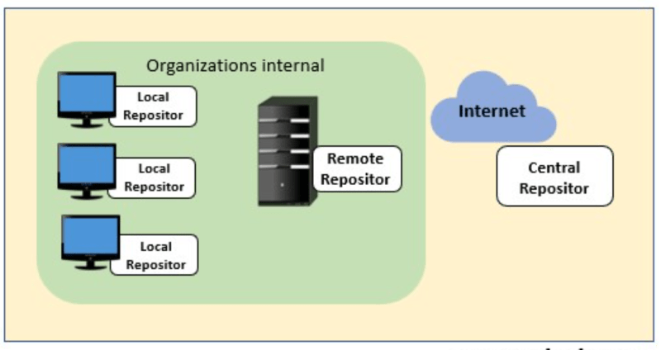

* Workflows:
  + After every night build push the artifacts to remote repo
  + when resolving dependencies use remote repository